**Дерево решений**

model = DecisionTreeRegressor(  
 random_state=1,  
 criterion = 'absolute_error',  
 min_samples_leaf = 3 ,  
 max_depth = 200  
)

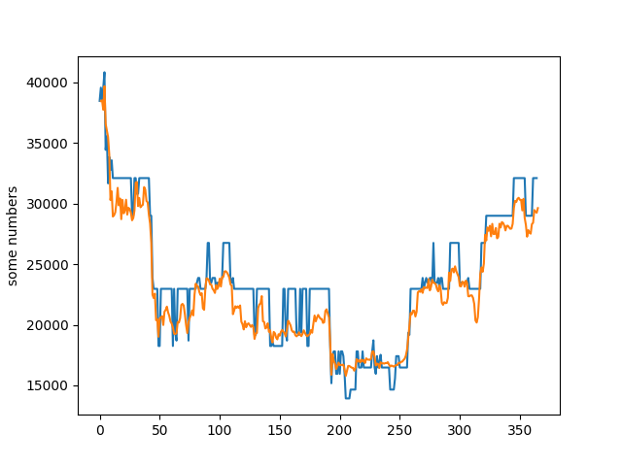

**Случайный лес**

model = RandomForestRegressor(  
 criterion = 'absolute_error',  
 n_estimators=900,#900 - 1000  
 min_samples_leaf = 1,#2 или 1  
 oob_score = True,  
 random_state = 1,  
 max_samples = 10  
)

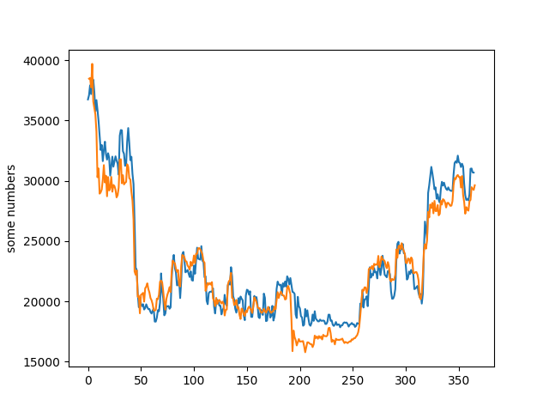

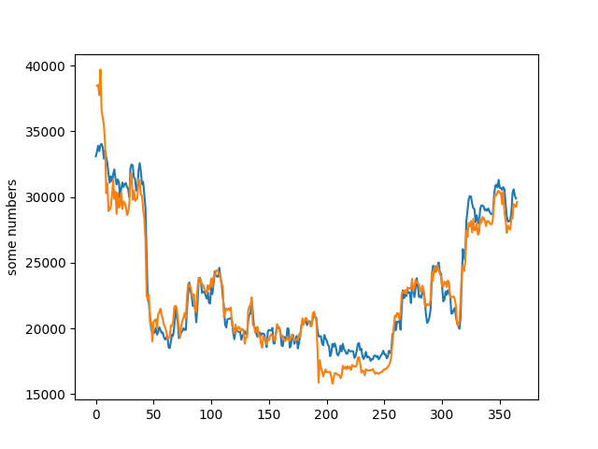model = RandomForestRegressor(  
 criterion = 'absolute_error',  
 n_estimators=900,#900 - 1000  
 min_samples_leaf = 2,#2 или 1  
 oob_score = True,  
 random_state = 1,  
 max_samples = 10  
)

model = RandomForestRegressor(  
 criterion='squared_error',  
 n_estimators=500, # 900 - 1000  
 min_samples_leaf=2, # 2 или 1  
 oob_score=True,  
 random_state=1,  
 max_samples=900  
)

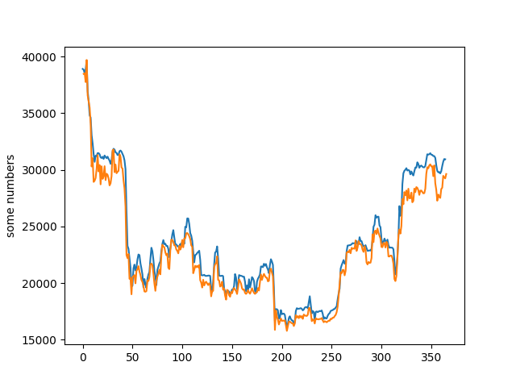

**Градиентный бустинг**

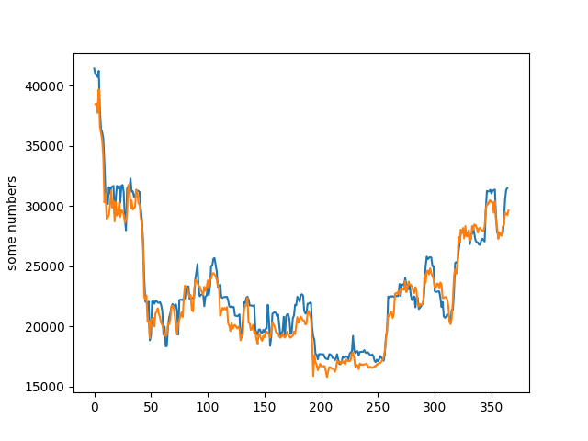model = GradientBoostingRegressor(  
 random_state=1,  
 loss='quantile',  
 n_estimators = 250,  
 max_depth = 15,  
 criterion = 'squared_error',  
 learning_rate= 0.025,  
 min_samples_leaf= 2,  
 min_samples_split= 2  
  
)